Joe Mack Student Center Research Report
Ethnography for Designers - IAD 3300

Team Eckert
Tyler Eckert | Natalia Navaroli | Nicole Kadom | Amara Bush

Executive Summary

Summary:
This report represents the findings of our team’s ethnographic research on the student center, located on Kennesaw State University’s Marietta campus. Combined, our team conducted 40 hours of observation in the field and conducted four interviews. Our collective findings are summarized in this report.
Research Question: "What does hanging out at the Joe Mack student center mean to you?"

Objectives:
- Find out the main motivations for students visiting the student center

- Find out how the student center affects students’ experience on campus

- Find out what students
typically do when visiting the student center

- Find out student’s attitudes towards the student center

- Figure out what purpose the student center serves on campus
Findings:
Our team came together and analyzed our data from observation sessions and interviews, and identified these key points:

Food
Students frequently visit the student center to get food. They often visit Chick fil A and Dunkin Donuts. Often times, they just grab the food and go, but sometimes they will sit and eat it in the student center.

Study
We learned that many students go to the student center as a place to study and get work done. This is because the student center has working outlets, and tables where students can do homework

Social Gathering
Many students use the student center as a place to meet with their friends and catch up. There are many large tables where students sit with their friends and talk while enjoying food

Table of Contents

Executive Summary 2

Introduction 4

Contextual Research 5

Methodology 8

Observation Period- Amara 10

Interviews 11

Analysis- Amara 13

Conclusion - Tyler 14

Works Cited 15

Introduction

Kennesaw State University is one the largest and fastest growing universities in Georgia currently. On January 6th, 2015, Kennesaw State merged with Southern Polytechnic State University, creating what we now know as the Marietta Campus of KSU. While offering different degrees and having renowned and respected professors is a large part of what makes people want to go to a school, there are other factors that also weigh in. One of these would be life on the campus. With this, we were interested in what KSU was providing students with, in order to keep their current goals and projection going.

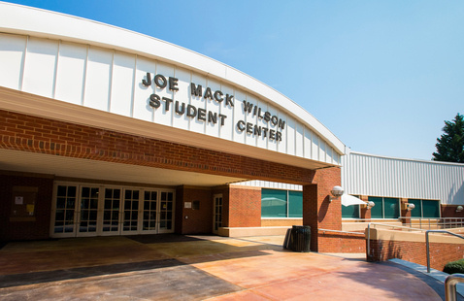
We decided to take a dive into a large part of what makes life on the Marietta Campus, the Joe Mack Student Center. The student center is a large building located off to the side of the campus. It houses many things that students will regularly come for. Some of these include Chick-Fil-A, a dance hall, a game room, and other things of the sort. The Student Center also provides a large amount of seating and outlets for students to spend some time with friends or to get their work done outside of class. It is easy to see the worth of the amenities that are provided, but we are interested in what this space actually means to students, not just what they can receive from it.

Contextual Research

For our ethnographic report, the field in which we had investigated was the Joe Mack Wilson Student Center, located on Kennesaw State University’s Marietta Campus.
First, we need to understand the purpose and the role of what defines a Student Center. While we did not find any descriptions from Kennesaw State University, North Carolina Agricultural and Technical State University describes their Student Center as,
“-the community center of the college, serving students, faculty, staff, alumni and visitors. It provides services and conveniences that members of the college community need in their daily lives and creates an environment for getting to know and understand others through formal and informal associations.” (“The Role of the Student Center”, n.d.)
Kennesaw State University’s Student Center is a building hosting many facilities provided to students on campus. This includes shared areas for seating, a game room, a food court consisting of fast-food restaurant chains, rooms designated for events, and a bookstore. In an article published by the Global Scientific Journal, it describes why these Student Center spaces are beneficial to students in Universities.
“According to Poecker (2014), the student Centre is the heart of a university. It brings students, faculty, and prospective students together, providing them with a so-called snapshot of the university and at the same time offering them a welcoming sense of community.” (“STUDENT CENTER AND THE CONCEPT OF LEARNING COMMONS INTRODUCTION”, n.d.)
The purpose of these spaces is to provide many different facilities to university students on a campus, while also promoting a sense of community, as the source previously refers to them as a “campus community center.”
Our research team decided to investigate a specific facility offered by KSU’s Student Center, being the general seating area or “lounge room.” This large seating area was located next to the food court with a few fast-food restaurant chains for dining.
Regarding these spaces, specifically, facilities designated for dining, we found sources suggesting that these spaces would benefit from renovating the traditional cafeteria space into a space that is more multifunctional. This is something we had initially observed with our field, as our field was multifunctional and unlike traditional dining spaces.
“It’s well known that people like to gather where food is served. Despite the many other comfortable rooms at a house party, the kitchen is oftentimes the most crowded space. And the college cafeteria is no exception. Improved effectiveness begins by understanding that food service spaces are typically used for a wide variety of important functions. A contemporary design acknowledges this, transforming the traditional cafeteria into a multi-purpose space…” (“3 Important Functions of the Modern College Food Service Space”, n.d.)
Another source suggests a similar idea from an architectural perspective in the design of these spaces and what makes them effective.
“The spaces of a student center should range from the intimate scale of an individual corner or a small meeting room to the community scale of a bustling dining hall. Weaving these spaces together requires both logic and art, creating comfortable relationships and an accommodating ease of use. Carefully organized spaces and programs lead naturally to inclusive participation in the larger web of activity within the building making the student center come alive.” (Atkins 2016)
As we have previously established, these facilities are meant to build a shared community. Specifically, this space encourages communal dining. In an article titled, “Social Eating Connects Communities,” in which discusses social dining and individuals’ happiness, it states,
“The results suggest that communal eating increases social bonding and feelings of wellbeing and enhances one’s sense of contentedness and embedding within the community.” (“Social eating connects communities” 2017)
Results from a similar study state,
“-data from a UK national stratified survey to test the hypothesis that eating with others provides both social and individual benefits. I show that those who eat socially more often feel happier and are more satisfied with life, are more trusting of others, are more engaged with their local communities, and have more friends they can depend on for support.” (“Breaking Bread: the Functions of Social Eating”, n.d.)
While it builds a sense of community, there are studies also indicating that communal dining is beneficial to university students for other reasons as well, increasing the importance and need for these spaces to be provided. One study conducted by Kansas State University finds the correlation between frequent communal dining and higher GPA averages among students.
“Results related to grade point average and perceived social support revealed a significant positive relationship between frequency of eating in the dining center and grade point average for all participants combined. This relationship was also noted for males and females analyzed separately. Frequency of eating with others was found to be significantly positively correlated to perceived social support score for all participants combined, and for males and females analyzed separately. Frequency of eating with others was significantly positively correlated with grade point average for males alone and females alone, but not all participants combined.” (Bauer, n.d.)
Our team went into our field keeping this in mind during observation. While the facilities offered at the Student Center promote community, our team found our scope when researching the dining commons specifically to observe behavioral trends of students utilizing this space.

Methodology

The Field
Our field for this research report is the Joe Mack Wilson Student Center located at the Kennesaw State University Marietta Campus. The specific location we studied predominantly was the main seating area on the first floor. The space also included a large food court area with multiple fast-food restaurants. This space is designed for communal dining or a place for study for students. Initially, we went into the field starting with the research question surrounding the correlation between communal dining and the social life of students in university. However, over time in our observation, we found that the meaning of the space to students varied. Thus, our finalized research question became, “What does this space mean to students?”

Observation
Our observation period was our team’s time spent in the field. Our goal was to objectively observe trends and behaviors of students while engaging within this space. We collected our data with extensive note taking referred to as jottings, which are heavily detailed accounts of all events taking space at a given time. Our team looked for normal behaviors of students in the field. This included observing where students often lingered or engaged within the space. Each team member spent approximately 10 hours total in observation time. Each of us would enter the space completing our jottings on the field. Later, we would synthesize the information from the jottings into our finalized field notes. Our field notes were essential in taking out and analyzing recorded events in our jottings.

Interviews
Our team also conducted several random interviews with students at KSU who utilize the space. At this time, our interviews were conducted virtually. We asked each participant a series of questions about their thoughts and feelings about space regarding their past experiences. We prepared for our interview by establishing a list of interview questions to guide the conversation. Later, we were able to take the variables of the answers into account during analysis. Often, the team during the interview would establish one member as a moderator. The moderator is to conduct the interview. Meanwhile, the rest of the team members were facilitators. The role of the facilitators was to write extensive notes (jottings) during the time of the interview as spectators. Later, these jottings were also transcribed as field notes to be utilized in analysis.

Analysis
During analysis, the team met together to break down our data gathered in the field. Here, after synthesizing information into individual field notes, we were able to collaboratively sort out trends in our data using ordered matrices. Here, we organized two matrix tables. One table was devoted to data occurring in interviews, while the other was for data collected during individual observation. Here, the team was able to find data that was observed by all members, while finding the important data leading to our research question. We were able to conclude from our analysis, leading to a concise answer to our research question.

Reporting
In the final phase of this project, we build a cohesive report expressing the findings of our research. Here, we elaborate on our findings and their relevance in a greater context.

Observation Period
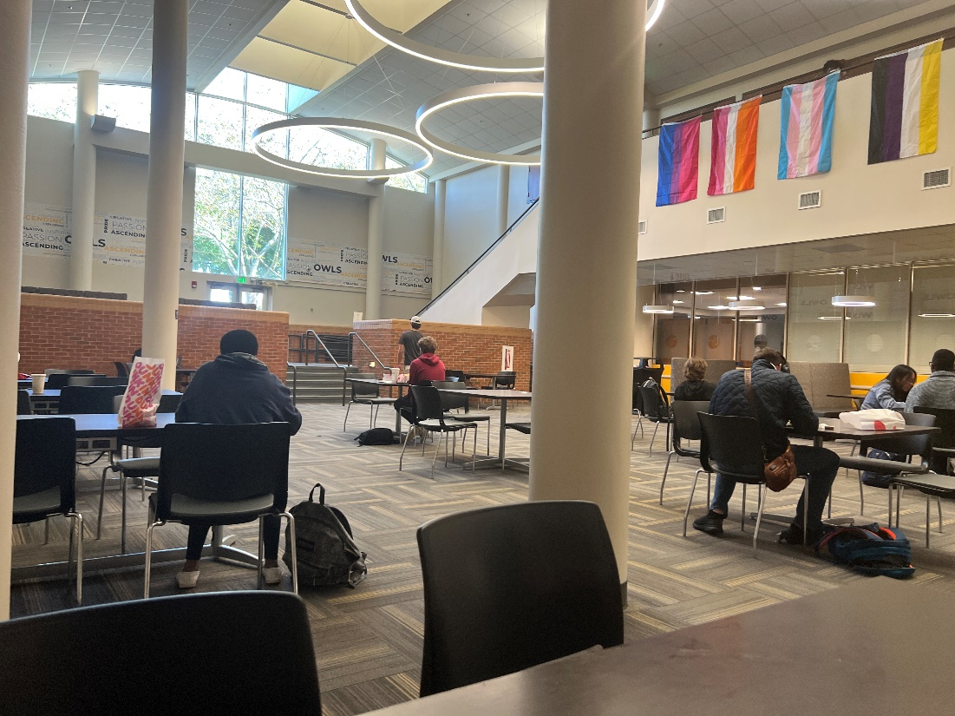

After defining our research question, we started observation. Each team member spent 10 hours in the field observing and doing jottings in our individual journals. Combined, we have a total of 40 hours of observation in the Student Center. Our jottings consisted of things such as the interactions we saw between students, the overall atmosphere of the student center, and anything we thought was interesting or relevant. We conducted observation in various areas of the student center, such as upstairs, downstairs, and near the restaurants. After each observation session, each team member made field notes in their journals. A field note essentially summarizes the key takeaways from that observation session, to make it easier to analyze all of the data later on.

The people we observed in the student center were primarily students and faculty members at KSU. The majority of students in the Student Center were simply picking up food and leaving. Many students also sit by themselves and take advantage of the outlets to charge their laptops and do assignments. While many students did sit with their friends, this did not seem to be the case for the majority. We started to realize at the Student Center functions as more of a utility rather than a community space.

The busiest area of the student center on the bottom floor, where the Chick-Fil-A, Hissho Sushi, Jamba Juice, and Dunkin Donuts are located. Around lunchtime, there is always a long line at Chick-Fil-A, and the tables are generally always full. In the mornings, Dunkin Donuts also gets a decent amount of students, but still not as much as Chick-Fil-A. We rarely saw people order sushi or smoothies from Jamba Juice. Sometimes, we observed students bringing their lunches from home, but most of the time they were eating Chick-Fil-A. We speculated that this may be because Chick-Fil-A is such a popular and well-known food chain, and many students prefer it over the others because the dining options on campus are so limited.

A large amount of students we observed had headphones in, or and were looking at their laptops or phones. Even when meeting with groups of friends, they would all often be looking at their phones instead of engaging with each other. Most of the students that were doing homework at the tables had headphones in as well, this may be because they do not want to be approached and want to be left alone. The student center can get quite noisy when there is a lunch rush at Chick-Fil-A, so the headphones may help students drown out noise and focus while they are working.

We often observed groups of students sitting together and dining. They would usually sit at the tables on the bottom floor. We originally thought that the student center would function as more of a community meeting place, but the groups of students we saw were far outnumbered by students who were sitting alone or just passing through. Many of these groups seemed to be gathering to work on classwork and projects together, but there were still several that were there just to have fun and talk. We witnessed many students unexpectedly run into their friends at the student center as well, but often times they were just passing through rather than staying to hang out and catch up. However, they would stay to chat if they were waiting in line for food.

The vast majority of students we observed at the student center were sitting alone and doing homework on their laptops. Often times, they would be eating food while working, but many are there solely for the purpose of working, especially upstairs. The upstairs was almost always silent and full of people on their devices. The tables were almost always taken up by people sitting alone, which was interesting because most of them were large and looked like they were meant to seat groups of people. This could mean that there is a lack of other places to sit on campus with food nearby, as well as a lack of working outlets.

The biggest takeaway we had from our observations is that the function of the student center is subjective to the individual, but tends to be more of a utility rather than a communal gathering place. We came to this conclusion due to the fact that the majority of the students were just there to get food and leave, or were sitting by themselves doing homework and charging their devices.

Interviews

Our team interviewed 4 total participants about their experiences in the Marietta Campus student center. We asked them a variety of questions to help us further understand the meaning of the student center to them as students. Our interviews were conducted virtually through Zoom and Discord.

Our first participant seemed very disappointed in the dining options not only in the student center but also on the entire campus as well. They thought that the Kennesaw campus has a much larger variety of places to get food and wished that the Marietta campus would be similar. They also said that they now eat their food cold, since KSU took away the microwave in the student center. They wished that there were healthier options on campus so that they wouldn’t always have to do this. They used to frequent the student center more often but stopped due to the lack of variety in dining options and not having a microwave accessible. They felt that the student center was more of a utility rather than a meaningful community center. When they do go to the student center now, it is just to meet with friends just because they do not have anywhere else to meet up.

Our second interview participants expressed that they enjoy going to the student center for the tables and outlets. They sometimes go to meet with friends or get food from Dunkin Donuts, but the primary reason they visit is generally for the tables and outlets. They said that they wish that the student center was more centrally located because that would make them more likely to visit. Typically, they just go to the areas that are near their next classes, which leads them to not visit the student center too often. Typically, they dine at Stacks instead of the student center, because they prefer its central location on campus. Occasionally, they will attend an event held in the student center, but they generally do not visit much since it is just too crowded.

Our third interview participant viewed the student center as a place to sleep or kill time. Even though they have dining dollars and a meal plan, they do not visit the student center regularly because of its lack of variety of dining options. They also said that the Chick Fil A in the student center takes way too long every time, which causes them to go off campus for food. They told us that they now stay in the Atrium between their classes because they prefer the food options there and they don’t have to wait as long. Otherwise, they usually go get food off campus at a nearby restaurant. They generally do not meet with friends in the student center, but they have gone for a blood drive before.

Our fourth participant lives on Kennesaw campus and has a meal plan. Though they live on Kennesaw campus, most of their classes take place on the Marietta campus. They felt that the student center would be way more popular if it was centrally located, and they usually just go to get Chick Fil A and leave. Sometimes, they go to study at the student center, they said that this is because it is the only place on campus with tables and working outlets.

Analysis

For this ethnographic study, our team investigated students’ social engagement in Kennesaw State University’s Student Center. Our study was conducted by on-site observation, one-on-one interviews, and team analysis. Our assumptions leading into the study, as well as our initial research question, focused on the social relationships and community building associated with communal dining. However, with new data being introduced over the course of the study, our team began shifting our research in a new direction. Our revised research question then became focused on the meaning of the space to students. We were able to measure this based on varying responses from individual interviews. For instance, the individual’s specific utilization of the space. We found certain individuals often entered the space solely for dining or individual work. These participants often reported being alone or without social interaction. However, other individuals viewed the space as an optimal location for social gatherings among their friends and peers. This is due to the space offering tables seating upwards of six while the space comes with no nuanced pressure for students to speak quietly or not speak at all. Characteristics of these individuals were also congruent with being more aware of or involved in other social functions held in the space, often offered by the school. This dichotomy was also evidenced during observation. There were often many students focused on individual tasks, while many others were there in groups and meetups. Thus, the meaning of the space, as it is a multifunctional facility, is often subjective to the student.

Conclusion - Tyler

To summarize the project, we generally followed the guidelines on Sam Ladner’s book, Practical Ethnography: A guide to Doing Ethnography in the Private Sector, to complete ethnographic research on the Joe Mack Student Center located on the Marietta Campus of Kennesaw State University. Through this, we were able to answer our research question, “What does spending time at the Joe Mack Student Center mean to you?” To our understanding, the Student Center functions more as a utility, rather than a space that has special meaning to students. Though there are students who do meet up and go to events, the space mainly functions as a place to grab food, or to sit down and plug in your laptop. The student center is like a library, but with fast food. The societal aspect around food in the American culture wasn’t necessarily applied to this field.

While it doesn’t fit our prior assumptions of the field, it isn’t entirely surprising knowing the general culture of students on the campus. It is interesting to see how our prior judgments without spending a lot of time in the field prior was proven wrong. It is another example of not judging a book by its cover. The curiosity now remains of how many other areas in the world we judge from face value could be entirely different once you are completely immersed in that culture. There is only one way for this to be discovered. Step out of your comfort zone and dive in headfirst.

Works Cited

References
Atkins, Joe. 2016. “Student Center Design.” VMDO Architects. https://www.vmdo.com/architecture-blog/student-center-design/.
Bauer, Abigail. n.d. “The effects of communal eating on perceived social support and academic success in first year college students.” K-REx. Accessed November 23, 2022. https://krex.k-state.edu/dspace/handle/2097/13643.
“Breaking Bread: the Functions of Social Eating.” n.d. NCBI. Accessed November 23, 2022. https://www.ncbi.nlm.nih.gov/pmc/articles/PMC6979515/.
“The Role of the Student Center.” n.d. North Carolina A&T. Accessed November 23, 2022. https://www.ncat.edu/campus-life/student-affairs/departments/student-center/the-role-of-the-student-center.php.
“Social eating connects communities.” 2017. University of Oxford. https://www.ox.ac.uk/news/2017-03-16-social-eating-connects-communities.
“STUDENT CENTRE AND THE CONCEPT OF LEARNING COMMONS INTRODUCTION Student Centre is a building or facility dedicated to students.” n.d. Global Scientific Journal. Accessed November 23, 2022. https://www.globalscientificjournal.com/researchpaper/Students_centre_and_the_concept_of_learning_commons.pdf.
“3 Important Functions of the Modern College Food Service Space.” n.d. Falcon Products. Accessed November 23, 2022. https://www.falconproducts.com/blog/news/3-important-functions-of-the-modern-college-food-service-space.

